**Assignment 6.1**

1. Create a databse custom using below command

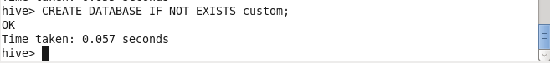

1. Verify our database created or not

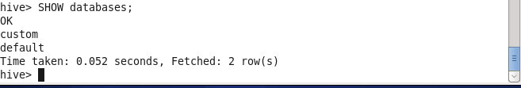

3 ) Create a table

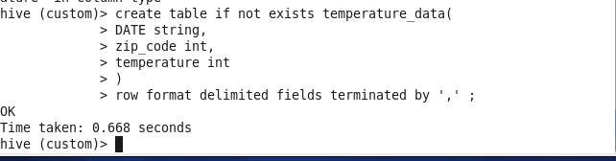

1. Load the data into table

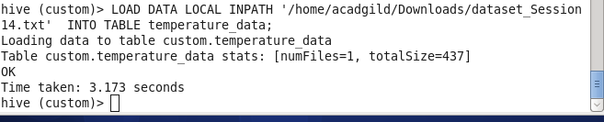

1. We can verify that data is loaded or notusing select command

